1. Create a box and whisker plot by class using mtcars dataset.

To make a box-whisker plot (aka box plot), use plot() and pass it x values that are categorical (aka factor) and a vector of y values. However, you need to ensure that the x values are factors otherwise you will get a scatter plot by default:

v# if x is not a factor it will produce a scatter plot

|  |
| --- |
| > plot(mtcars$cyl, mtcars$mpg) |
|  |
| |  | | --- | | > | |

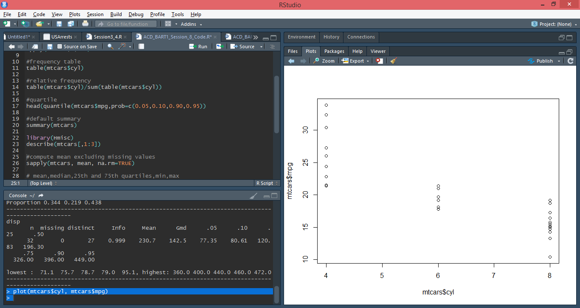

When x is a [factor](https://uc-r.github.io/factors) (as opposed to a numeric vector), it will automatically create a box plot:

plot(as.factor(mtcars$cyl), mtcars$mpg)

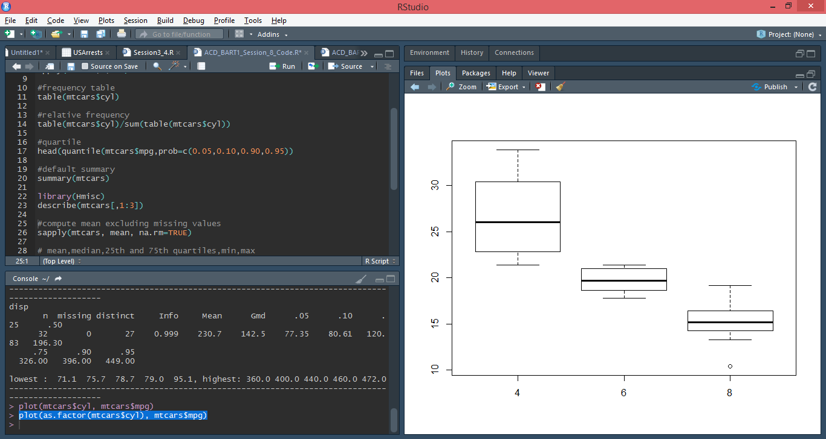

Alternatively, we can use the boxplot() function to create a box plot. We can create a single box plot with the following:

boxplot(mtcars$mpg)

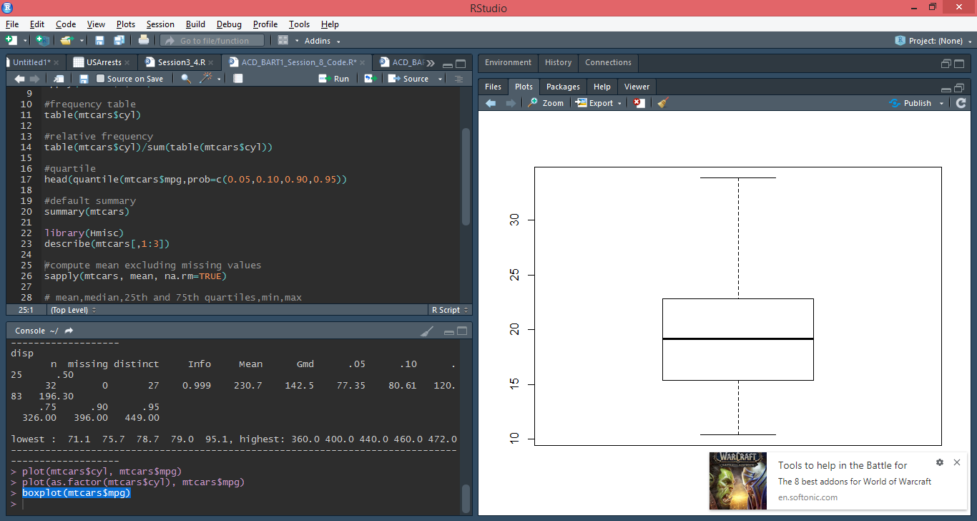

To get a box plot that displays the distribution of mpg values across the different cylinders we use the “~” to state that we want to assess y by x:

> boxplot(mpg ~ cyl, data = mtcars)

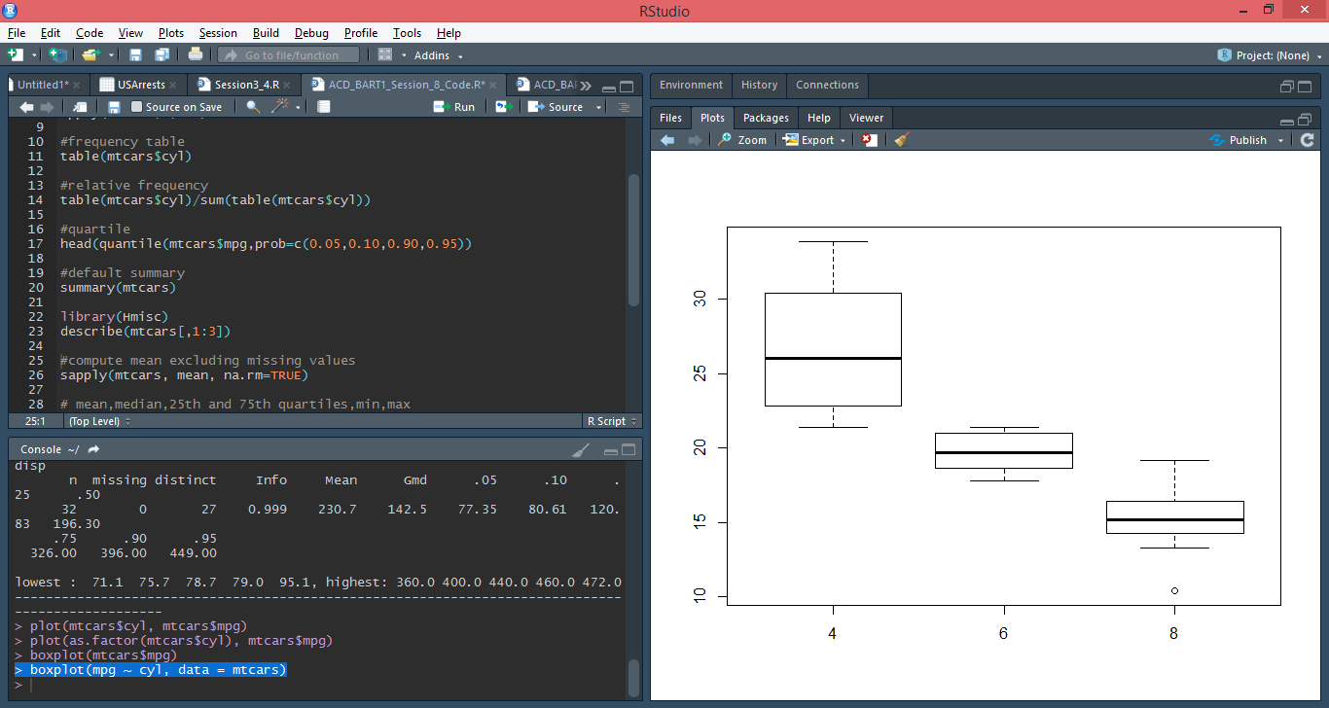

We can also assess interactions. In this case we look at the distribution of mpg by cylinders and transmission. Note on the y axis is mpg and on the x axis are the cylinder ~ transmission interaction. Note that the transmission variable is coded as 0 for automatic and 1 for manual. So the x-axis values of 4.0, 6.0, 8.0, 4.1, etc. represent 4 cylinder with automatic transmission, 6 cylinder with automatic transmission, 8 cylinder with automatic transmission, 4 cylinder with manual transmission, etc.

boxplot(mpg ~ cyl + am, data = mtcars)

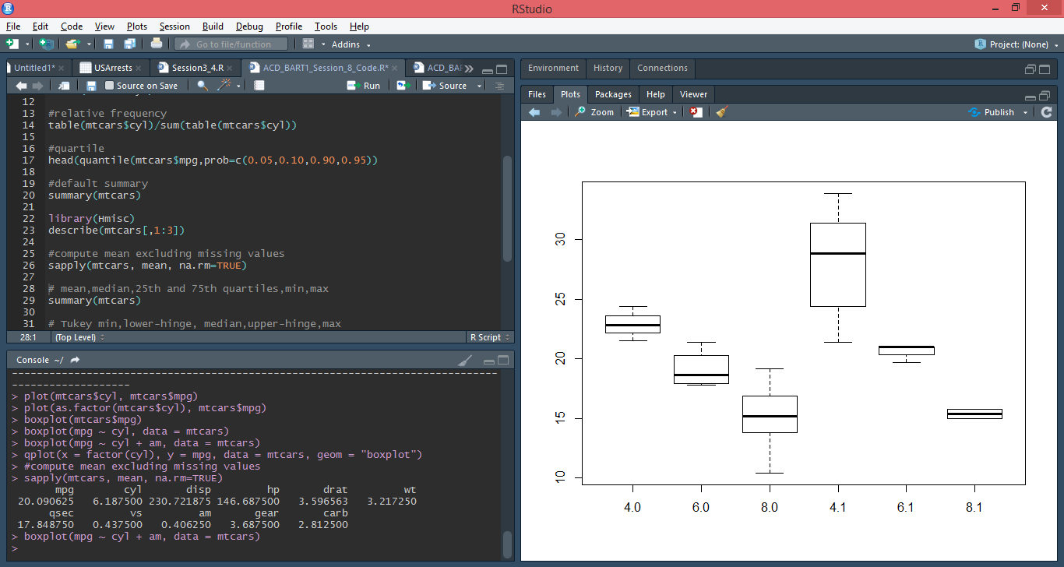

Similar results are attained with qplot() using geom = "boxplot":

qplot(x = factor(cyl), y = mpg, data = mtcars, geom = "boxplot")

